**SPRINT 1 REQUIREMENTS ARTIFACT**

1. Ability to login (Requirement-ID 2)
2. Follow other users (Requirement-ID 4)
3. Send messages to other users (Requirement-ID 6)
4. Real-time messaging with other users (Requirement-ID 7)
5. Ability to make posts (Requirement-ID 8)
6. UI must be appealing and intuitive (Requirement-ID 11)
7. Ability to play other users in a game of tic-tac-toe (Requirement-ID 12)

For all the above requirements, the “user interface model” is used, and the screenshots are presented on the following pages:

1. Ability to login (Requirement-ID 2)

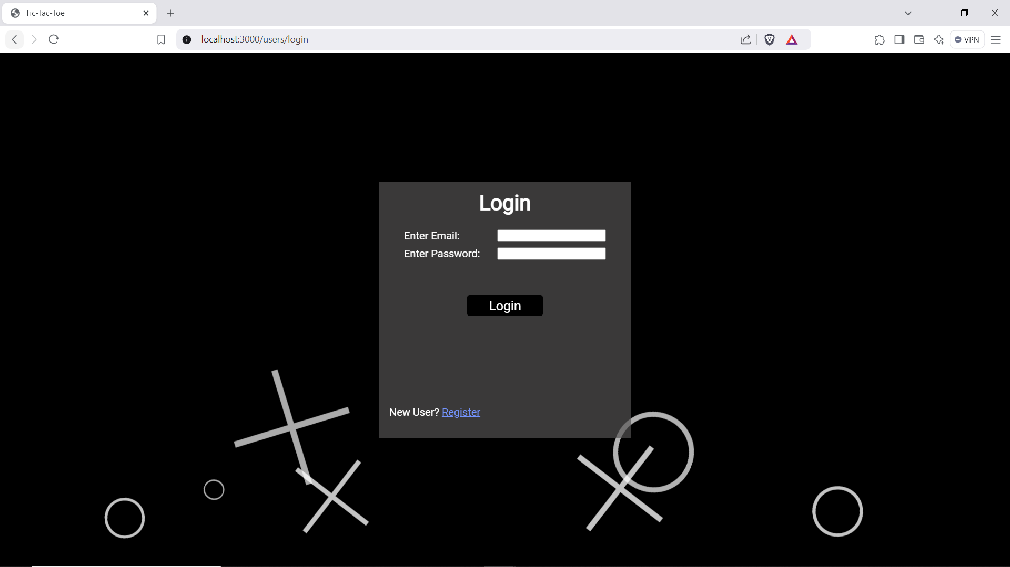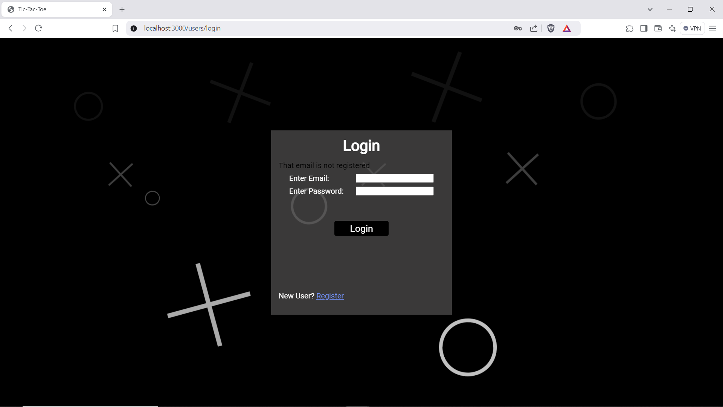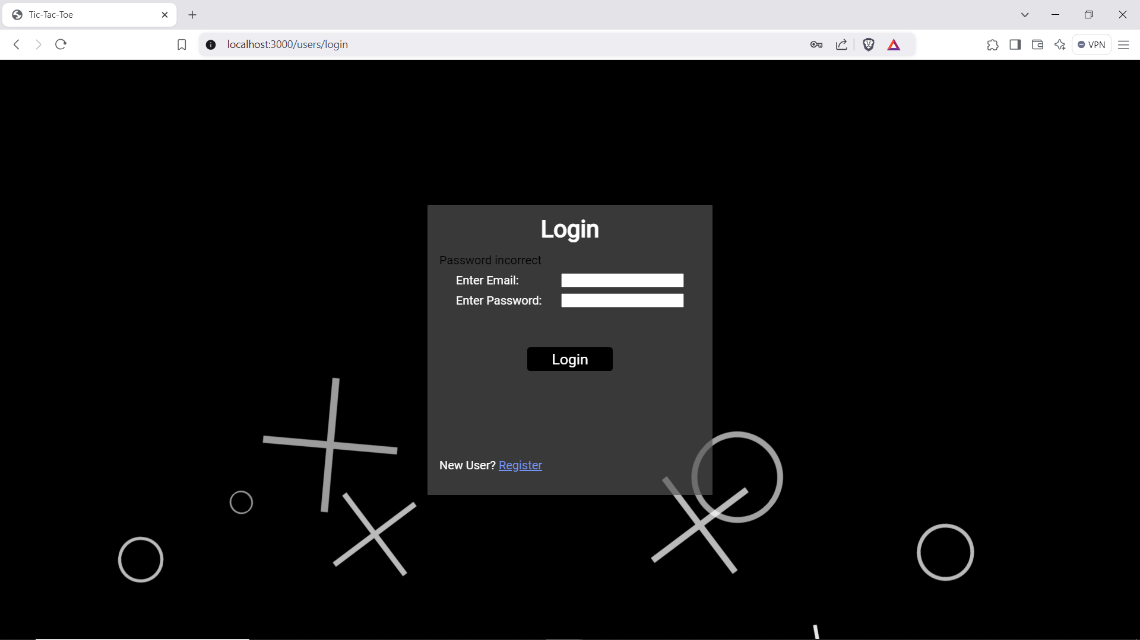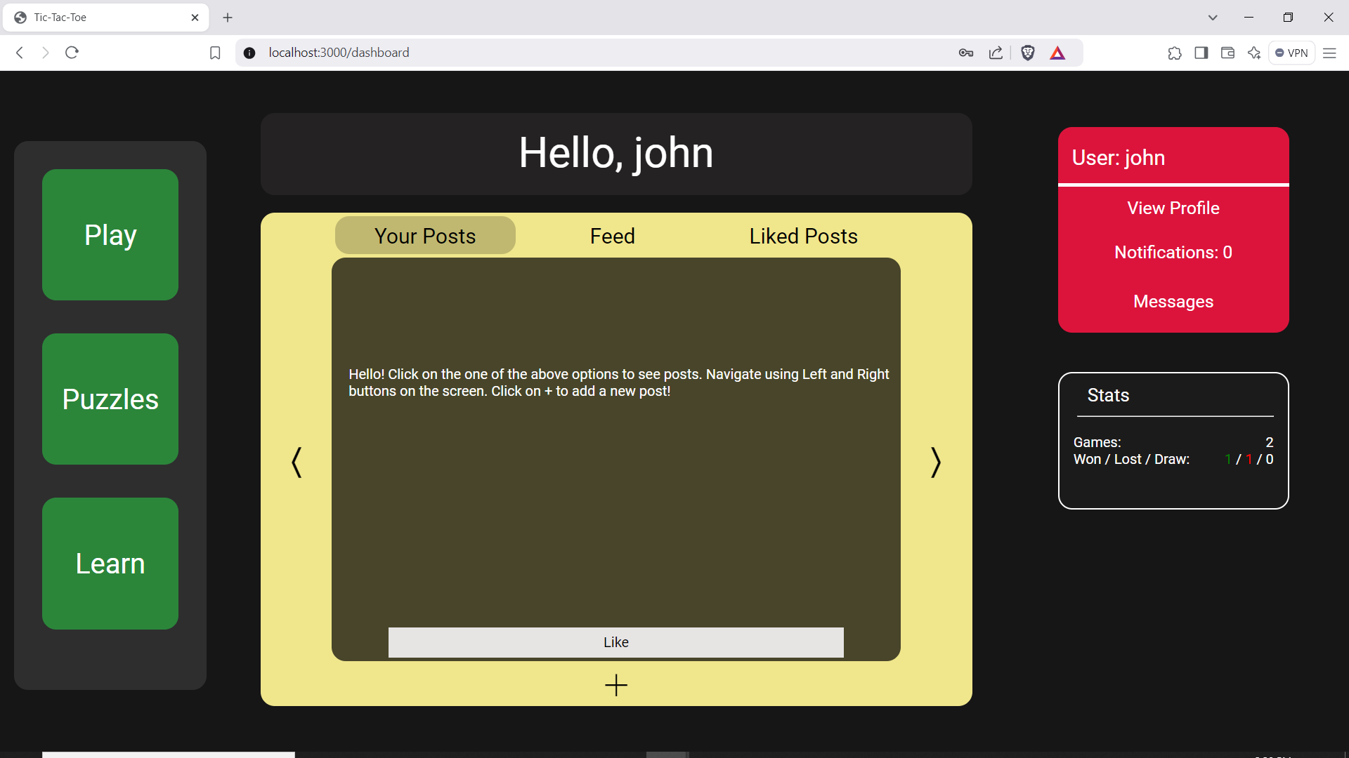

1. Follow other users (Requirement-ID 4)

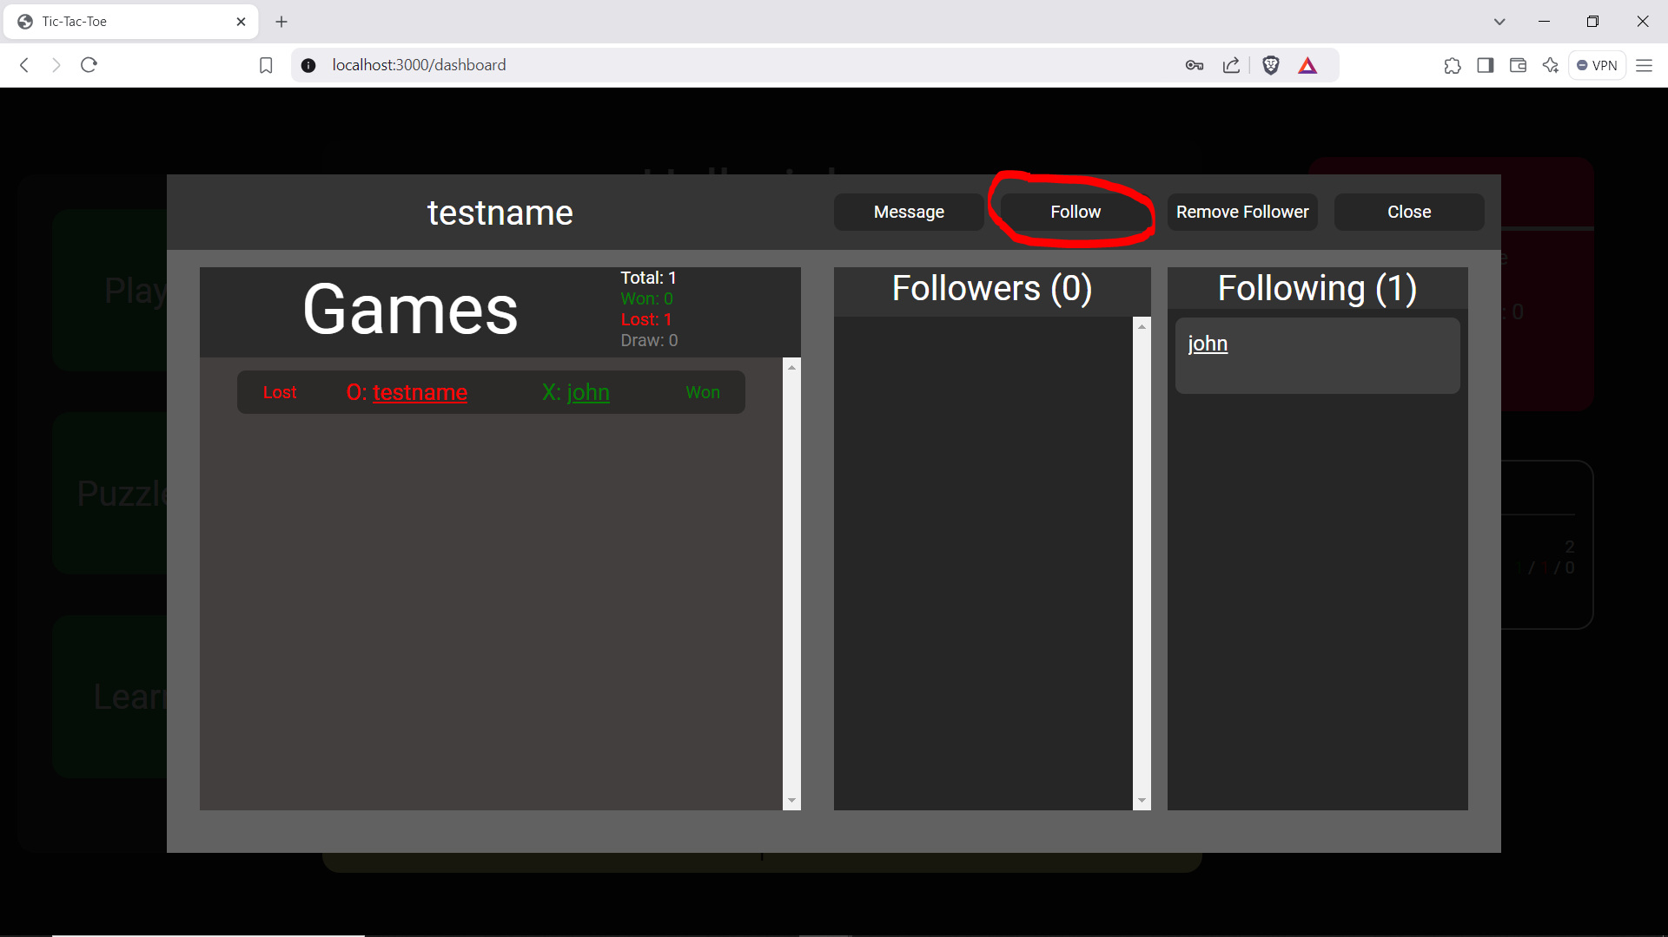

1. Send messages to other users (Requirement-ID 6)

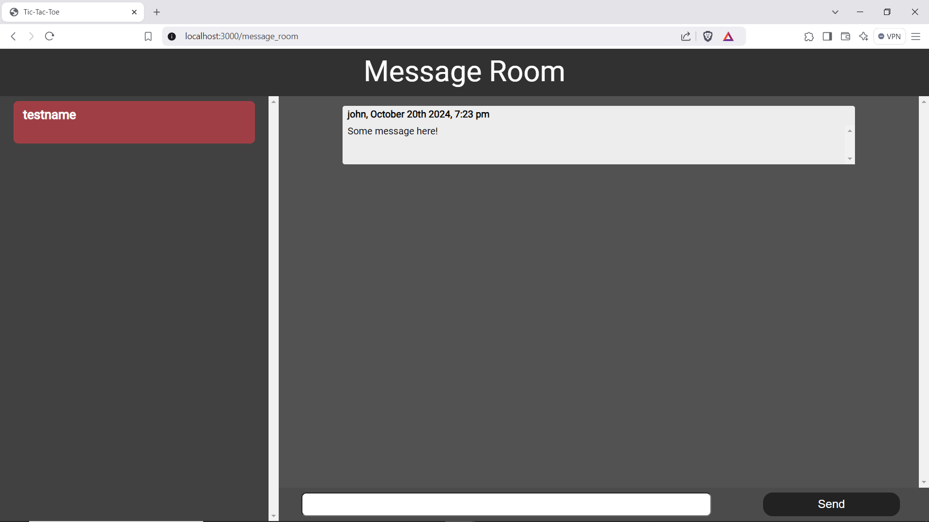

1. Send messages to other users (Requirement-ID 7)



1. Ability to make posts (Requirement-ID 8)

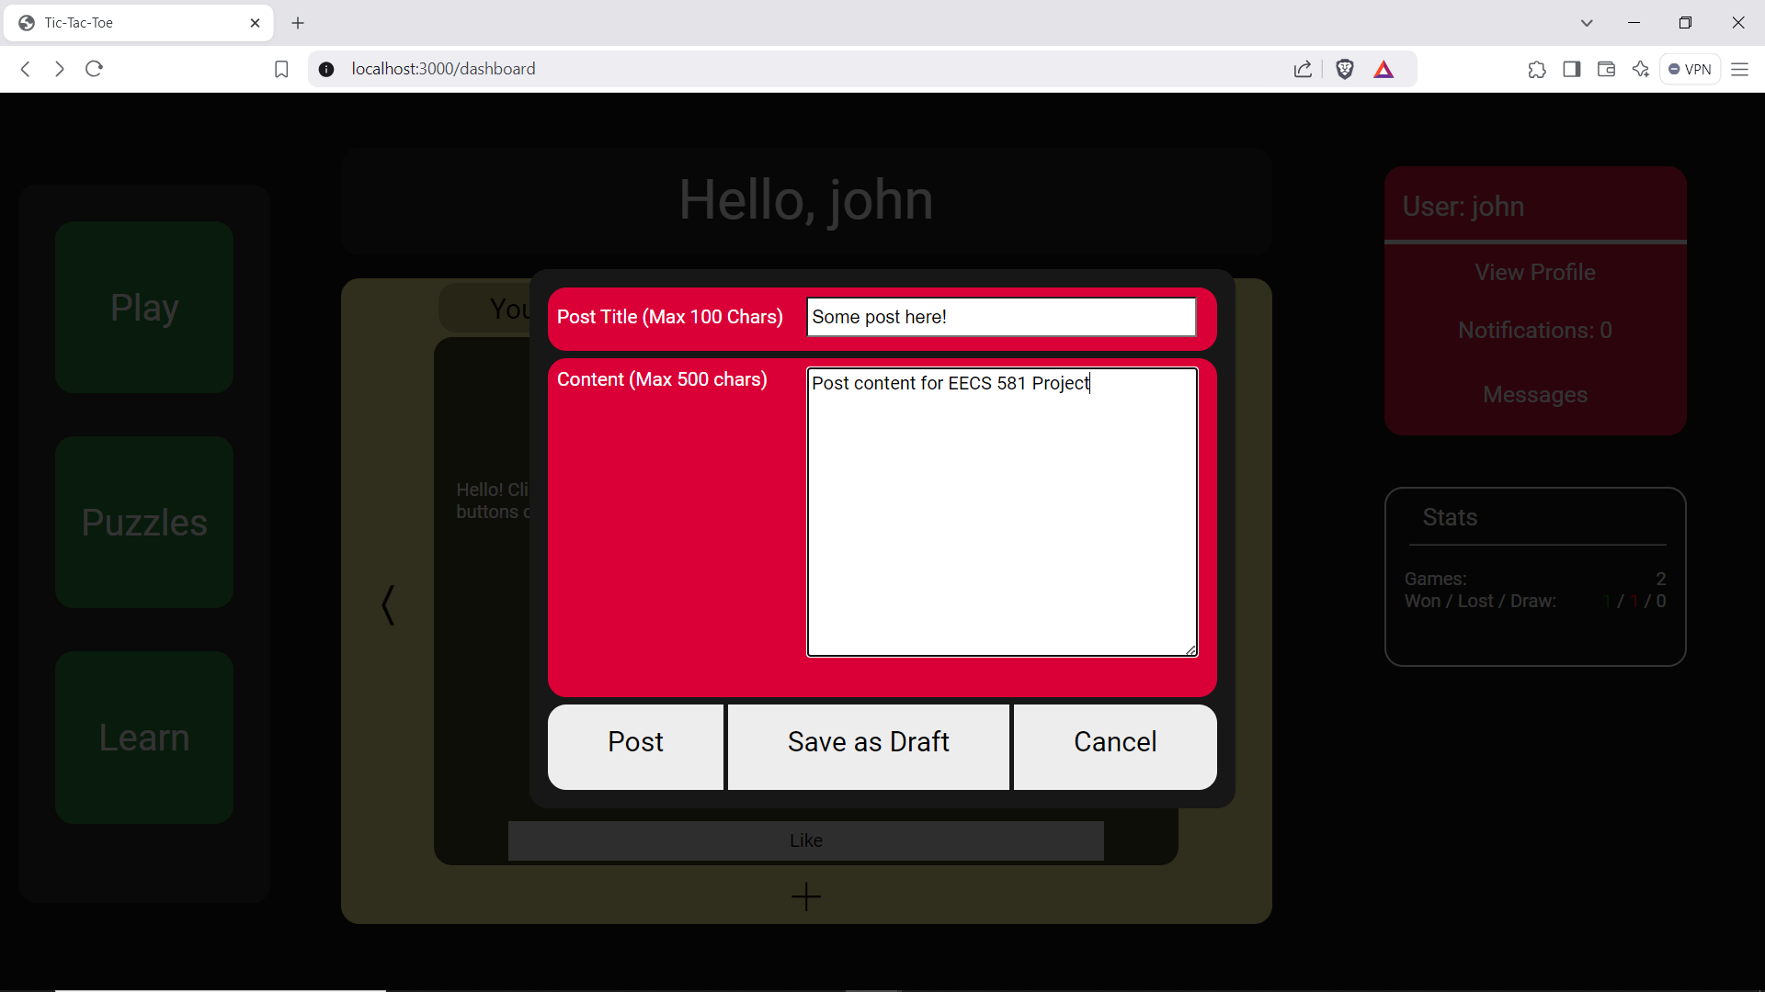

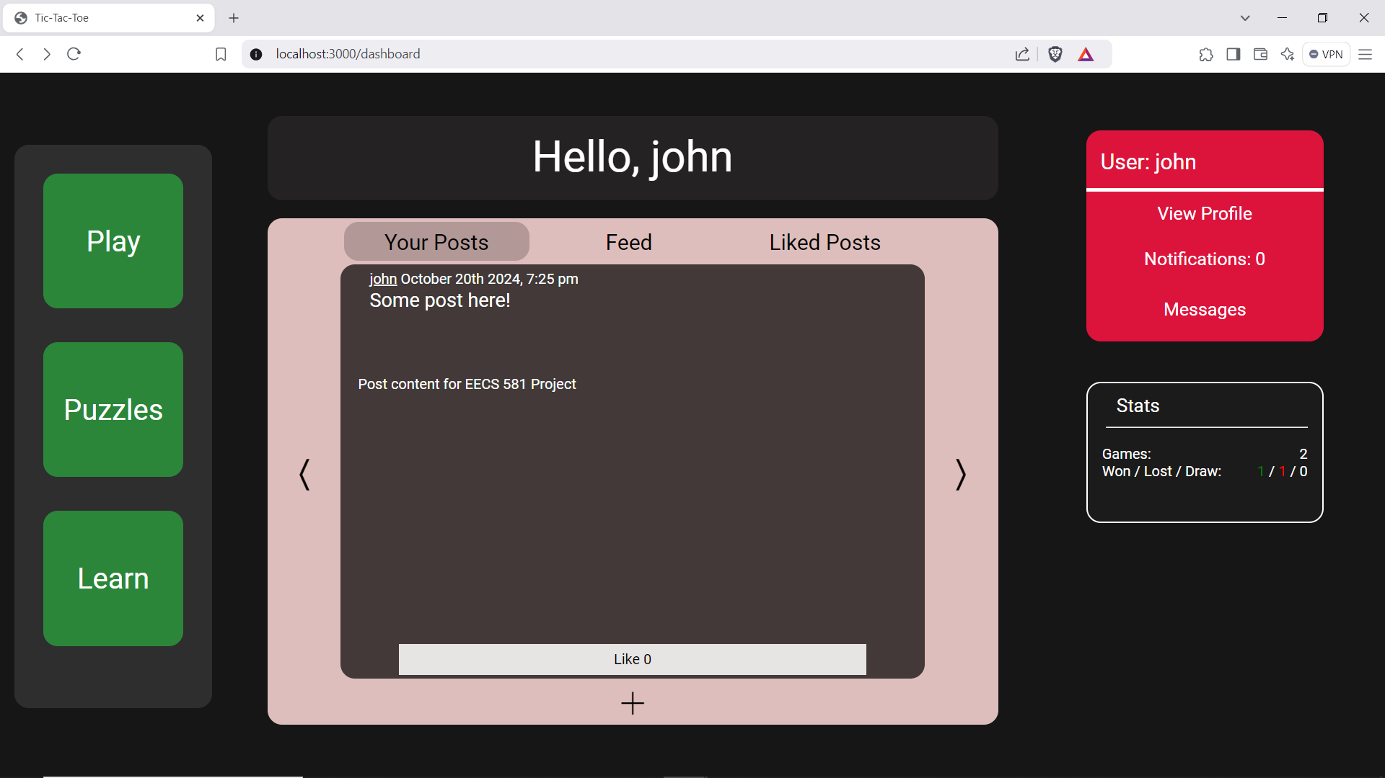

1. UI must be appealing and intuitive (Requirement-ID 11)

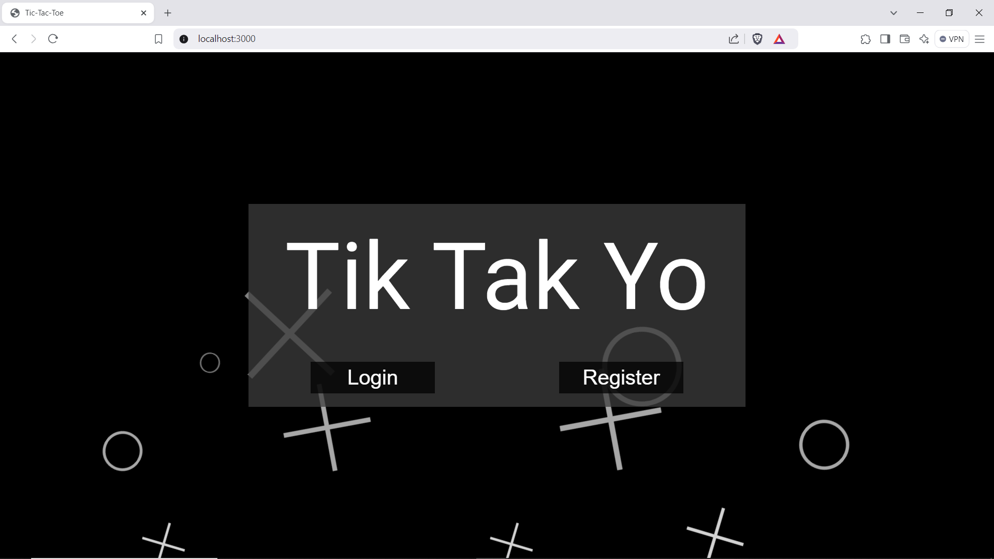

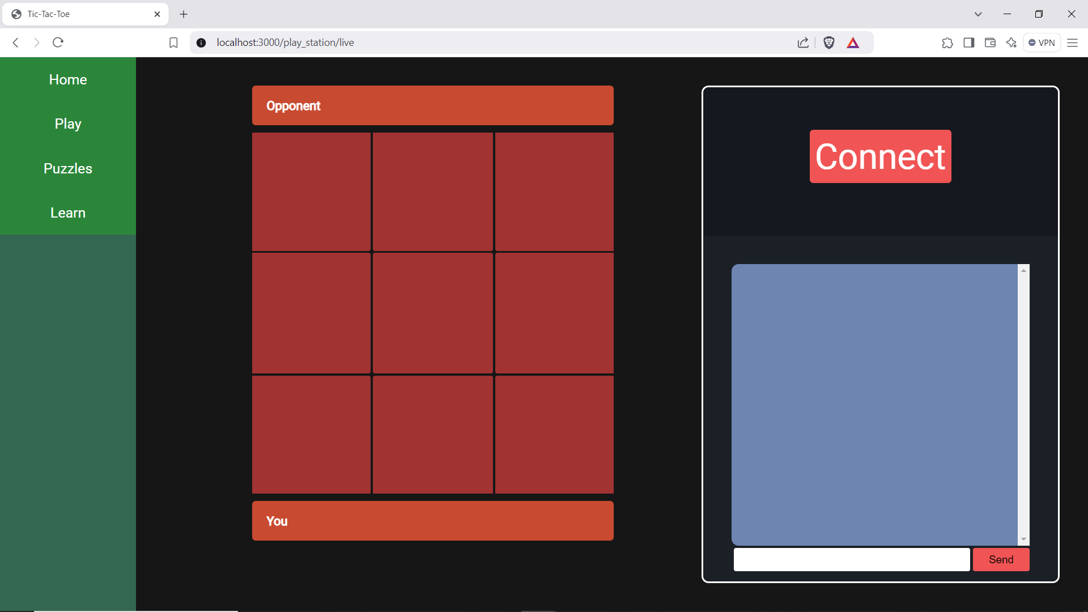

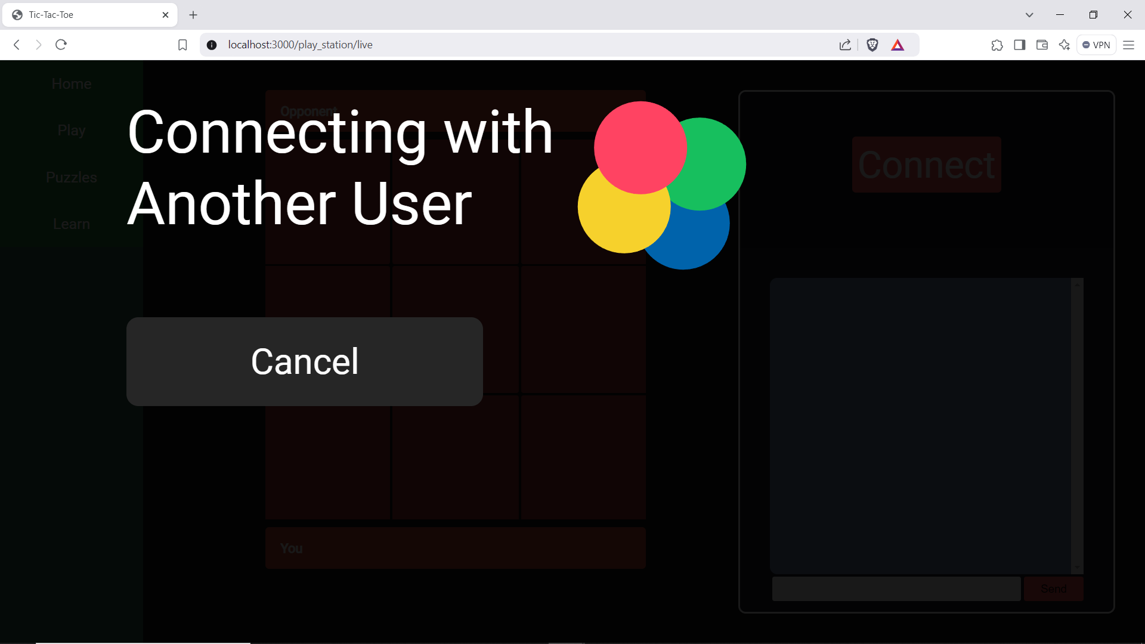

1. Ability to play other users in a game of tic-tac-toe (Requirement-ID 12)

